**GAM/IT/2022/F/0066 - S.A.N.S.Subasingha**

**Lab Sheet : Java Servlet**

**1: Simple Servlet - Display Static Message**

package com.example;

import java.io.IOException;

import java.io.PrintWriter;

import javax.servlet.ServletException;

import javax.servlet.annotation.WebServlet;

import javax.servlet.http.HttpServlet;

import javax.servlet.http.HttpServletRequest;

import javax.servlet.http.HttpServletResponse;

@WebServlet("/displayMessage")

public class DisplayMessageServlet extends HttpServlet {

protected void doGet(HttpServletRequest request, HttpServletResponse response)

throws ServletException, IOException {

response.setContentType("text/html");

PrintWriter out = response.getWriter();

out.println("<html><body> ");

out.println("<h1>Welcome to the Java Servlet Lab!</h1**>**");

out.println("</body></html>");

}

}

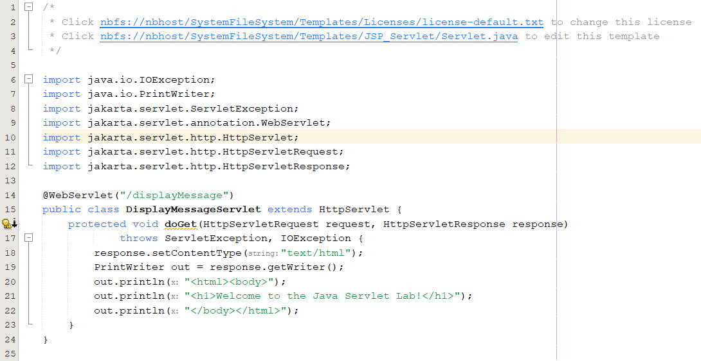

**Deployment Descriptor (web.xml) (if not using annotations):**

<web-app xmlns="http://java.sun.com/xml/ns/javaee"

version="3.0">

<servlet>

<servlet-name>DisplayMessageServlet</servlet-name>

<servlet-class>com.example.DisplayMessageServlet</servlet-class>

</servlet>

<servlet-mapping>

<servlet-name>DisplayMessageServlet</servlet-name>

<url-pattern>/displayMessage</url-pattern>

</servlet-mapping>

</web-app>

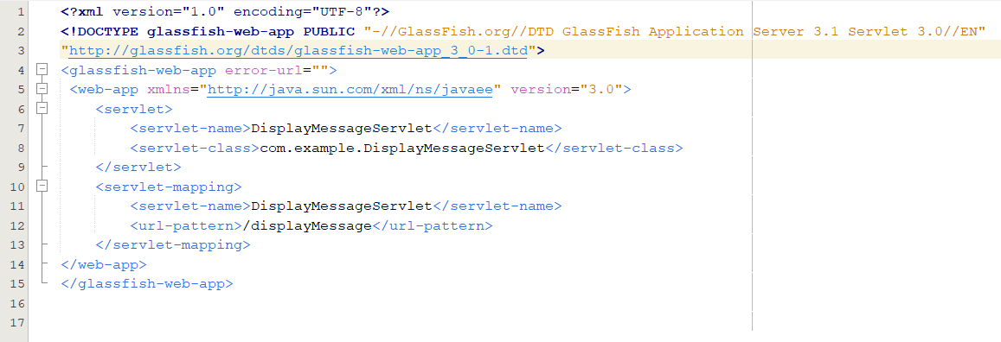

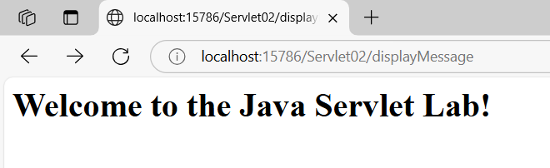

**2: Get User Input from Form and Display**

HTML Form (index.html):

<!DOCTYPE html>

<html>

<head><title>Input Form</title></head>

<body>

<form action="getUserInput" method="POST">

Name: <input type="text" name="username" required><br>

<input type="submit" value="Submit">

</form>

</body>

</html>

**Servlet Code (GetUserInputServlet.java):**

package com.example;

import java.io.IOException;

import java.io.PrintWriter;

import javax.servlet.ServletException;

import javax.servlet.annotation.WebServlet;

import javax.servlet.http.HttpServlet;

import javax.servlet.http.HttpServletRequest;

import javax.servlet.http.HttpServletResponse;

@WebServlet("/getUserInput")

public class GetUserInputServlet extends HttpServlet {

protected void doPost(HttpServletRequest request, HttpServletResponse

response)

throws ServletException, IOException {

String username = request.getParameter("username");

response.setContentType("text/html");

PrintWriter out = response.getWriter();

out.println("<html><body>");

out.println("<h1>Hello, " + username + "!</h1>");

out.println("</body></html>");

}

}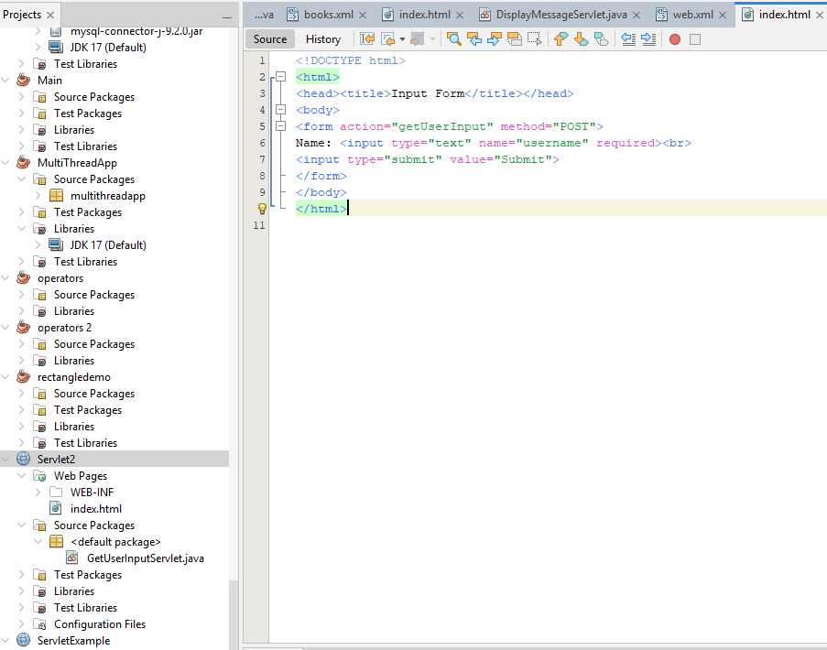

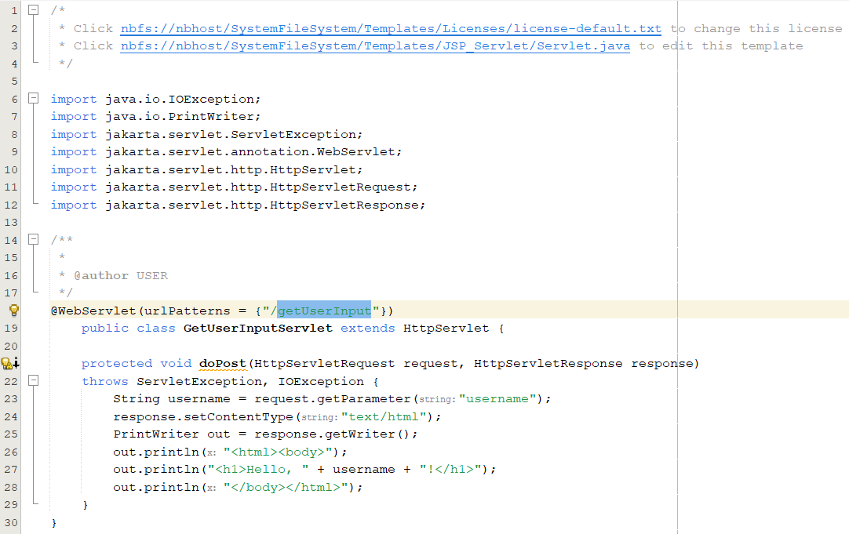

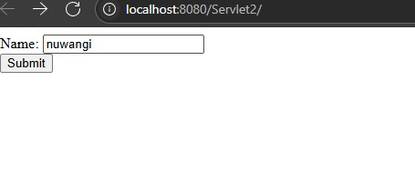

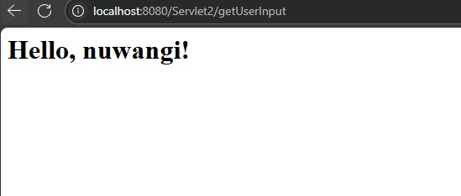

**3: Get Multiple Inputs, Perform Calculation, and Display Result**

**HTML Form (calculate.html):**

<!DOCTYPE html>

<html>

<head>

<title>Sum Calculator</title>

<style>

body {

font-family: 'Segoe UI', Tahoma, Geneva, Verdana, sans-serif;

background-color: #f5f7fa;

display: flex;

justify-content: center;

align-items: center;

height: 100vh;

margin: 0;

}

form {

background-color: white;

padding: 30px 40px;

border-radius: 12px;

box-shadow: 0 5px 15px rgba(0, 0, 0, 0.08);

width: 320px;

}

h2 {

text-align: center;

margin-bottom: 25px;

color: #4a6cf7;

font-size: 24px;

}

label {

display: block;

margin-bottom: 8px;

color: #555;

font-weight: 500;

}

input[type="number"] {

width: 100%;

padding: 12px 15px;

margin-bottom: 20px;

border: 1px solid #e0e0e0;

border-radius: 8px;

font-size: 16px;

transition: border 0.3s;

}

input[type="number"]:focus {

border-color: #4a6cf7;

outline: none;

}

input[type="submit"] {

width: 100%;

padding: 12px;

background-color: #4a6cf7;

color: white;

font-size: 16px;

font-weight: 500;

border: none;

border-radius: 8px;

cursor: pointer;

transition: background-color 0.3s;

}

input[type="submit"]:hover {

background-color: #3a5bd9;

}

</style>

</head>

<body>

<form action="calculateSum" method="POST">

<h2>Sum Calculator</h2>

<label for="num1">First Number:</label>

<input type="number" name="num1" id="num1" required>

<label for="num2">Second Number:</label>

<input type="number" name="num2" id="num2" required>

<input type="submit" value="Calculate Sum">

</form>

</body>

</html>

**Servlet Code (CalculateSumServlet.java):**

package com.example;

import java.io.IOException;

import java.io.PrintWriter;

import javax.servlet.ServletException;

import javax.servlet.annotation.WebServlet;

import javax.servlet.http.HttpServlet;

import javax.servlet.http.HttpServletRequest;

import javax.servlet.http.HttpServletResponse;

@WebServlet("/calculateSum")

public class CalculateSumServlet extends HttpServlet {

protected void doPost(HttpServletRequest request, HttpServletResponse

response)

throws ServletException, IOException {

int num1 = Integer.parseInt(request.getParameter("num1"));

int num2 = Integer.parseInt(request.getParameter("num2"));

int sum = num1 + num2;

response.setContentType("text/html");

PrintWriter out = response.getWriter();

out.println("<html><body>");

out.println("<h1>The sum of " + num1 + " and " + num2 + " is: " + sum

+ "</h1>");

out.println("</body></html>");

}

}

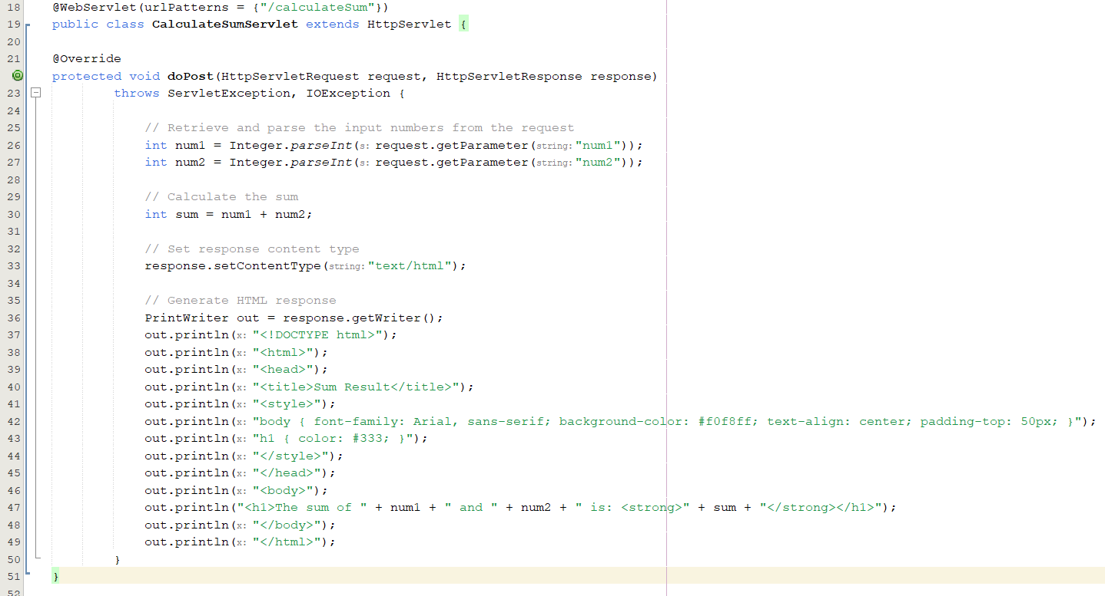

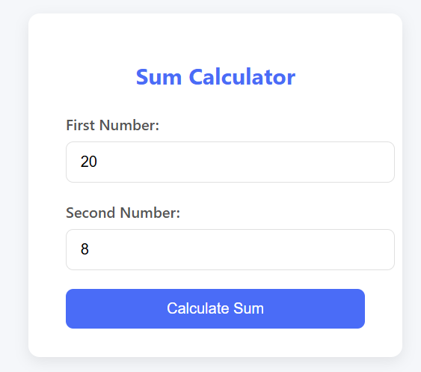

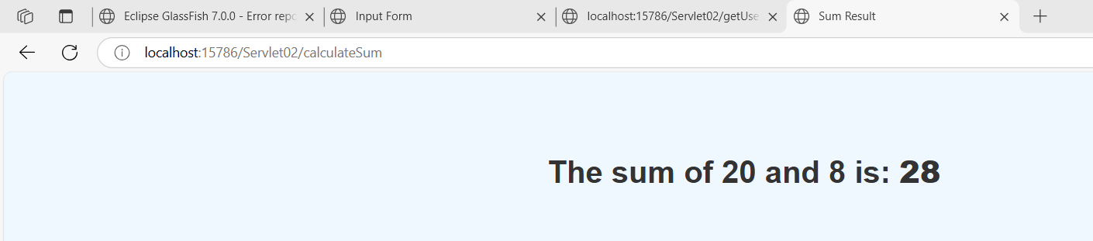

**4: Java Servlet with Database CRUD Operations**

**Database Setup (MySQL example):**

CREATE DATABASE stock_management;

USE stock_management;

CREATE TABLE stock (

id INT AUTO_INCREMENT PRIMARY KEY,

product_name VARCHAR(255),

quantity INT

);

**HTML Form (stockForm.html):**

<!DOCTYPE html>

<html lang="en">

<head>

<meta charset="UTF-8">

<title>Stock Management</title>

<!-- Bootstrap CSS CDN -->

<link href="https://cdn.jsdelivr.net/npm/bootstrap@5.3.0/dist/css/bootstrap.min.css" rel="stylesheet">

<style>

.card-header {

background-color: #6f42c1; /* Purple header */

}

.btn-add {

background-color: #20c997; /* Teal add button */

border-color: #20c997;

}

.btn-update {

background-color: #fd7e14; /* Orange update button */

border-color: #fd7e14;

}

.btn-delete {

background-color: #dc3545; /* Red delete button */

border-color: #dc3545;

}

body {

background-color: #f8f9fa;

}

.card {

border: none;

border-radius: 10px;

}

</style>

</head>

<body>

<div class="container mt-5">

<div class="card shadow">

<div class="card-header text-white">

<h2 class="mb-0">Manage Stock</h2>

</div>

<div class="card-body">

<form action="stockAction" method="POST">

<div class="mb-3">

<label for="product_name" class="form-label">Product Name:</label>

<input type="text" class="form-control" id="product_name" name="product_name" required>

</div>

<div class="mb-3">

<label for="quantity" class="form-label">Quantity:</label>

<input type="number" class="form-control" id="quantity" name="quantity" required>

</div>

<div class="d-flex gap-2">

<button type="submit" name="action" value="Add Product" class="btn btn-add text-white">Add Product</button>

<button type="submit" name="action" value="Update Product" class="btn btn-update text-white">Update Product</button>

<button type="submit" name="action" value="Delete Product" class="btn btn-delete text-white">Delete Product</button>

</div>

</form>

</div>

</div>

</div>

<!-- Bootstrap JS (Optional) -->

<script src="https://cdn.jsdelivr.net/npm/bootstrap@5.3.0/dist/js/bootstrap.bundle.min.js"></script>

</body>

</html>

**Servlet Code (StockManagementServlet.java):**

package com.example;

import java.io.IOException;

import java.io.PrintWriter;

import java.sql.*;

import javax.servlet.ServletException;

import javax.servlet.annotation.WebServlet;

import javax.servlet.http.HttpServlet;

import javax.servlet.http.HttpServletRequest;

import javax.servlet.http.HttpServletResponse;

@WebServlet("/stockAction")

public class StockManagementServlet extends HttpServlet {

private Connection getConnection() throws SQLException {

String url = "jdbc:mysql://localhost:3306/stock_management";

String username = "root";

String password = "root"; // replace with your database password

return DriverManager.getConnection(url, username, password);

}

protected void doPost(HttpServletRequest request, HttpServletResponse

response)

throws ServletException, IOException {

String action = request.getParameter("action");

String productName = request.getParameter("product_name");

int quantity = Integer.parseInt(request.getParameter("quantity"));

try (Connection conn = getConnection()) {

switch(action) {

case "Add Product":

try (PreparedStatement stmt = conn.prepareStatement(

"INSERT INTO stock (product_name, quantity)

VALUES (?, ?)")) {

stmt.setString(1, productName);

stmt.setInt(2, quantity);

stmt.executeUpdate();

response.getWriter().write("<h1>Product Added

Successfully</h1>");

}

break;

case "Update Product":

try (PreparedStatement stmt = conn.prepareStatement(

"UPDATE stock SET quantity = ? WHERE product_name

= ?")) {

stmt.setInt(1, quantity);

stmt.setString(2, productName);

stmt.executeUpdate();

response.getWriter().write("<h1>Product Updated

Successfully</h1>");

}

break;

case "Delete Product":

try (PreparedStatement stmt = conn.prepareStatement(

"DELETE FROM stock WHERE product_name = ?")) {

stmt.setString(1, productName);

stmt.executeUpdate();

response.getWriter().write("<h1>Product Deleted

Successfully</h1>");

}

break;

default:

response.getWriter().write("<h1>Invalid Action</h1>");

}

} catch (SQLException e) {

e.printStackTrace();

response.getWriter().write("<h1>Database Error: " +

e.getMessage() + "</h1>");

}

}

}

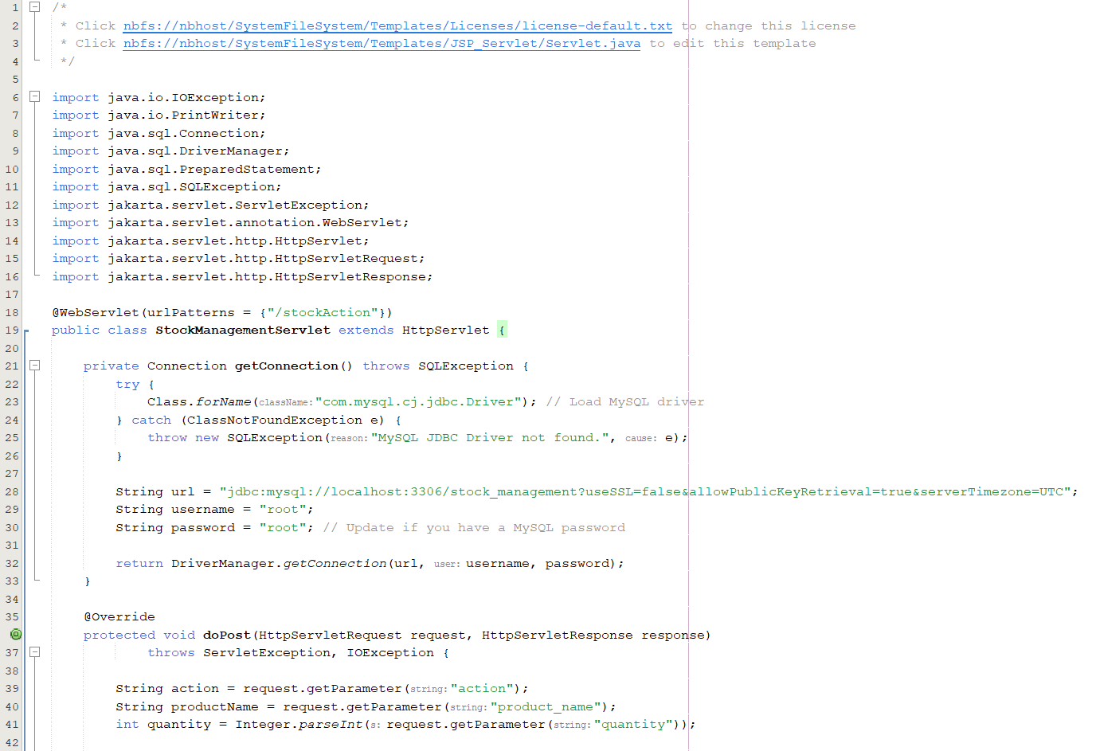

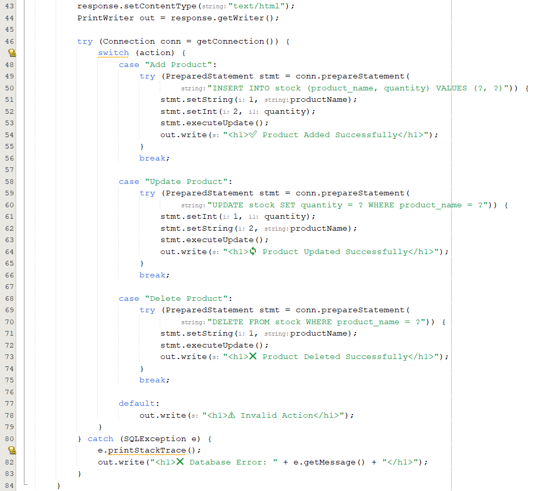

**Add :**

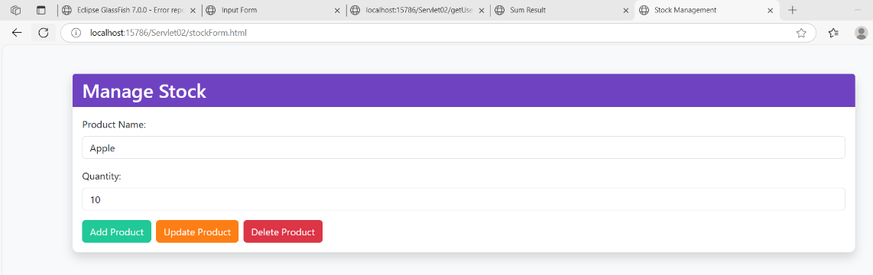

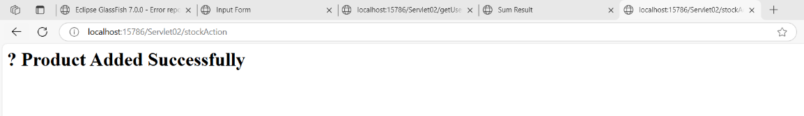

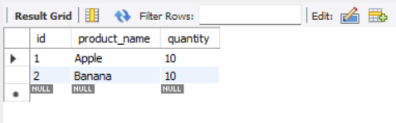

**Update:**

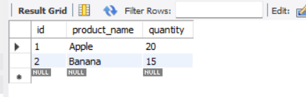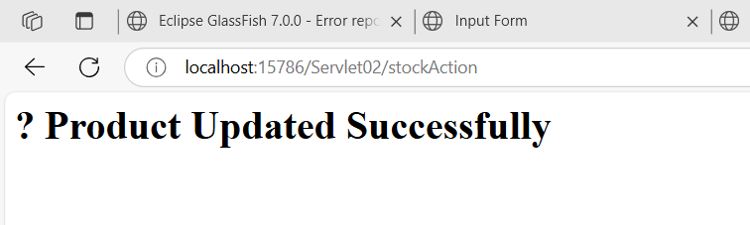

**Delete:**

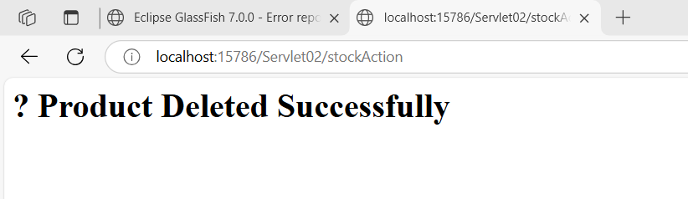

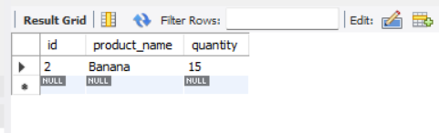

**5: Display Data from Database on Another Web Page**

@WebServlet(urlPatterns = {"/DisplayProducts"})

public class DisplayProductsServlet extends HttpServlet {

private Connection getConnection() throws SQLException {

try {

Class.forName("com.mysql.cj.jdbc.Driver"); // Load MySQL JDBC driver

} catch (ClassNotFoundException e) {

throw new SQLException("MySQL JDBC Driver not found.", e);

}

String url = "jdbc:mysql://localhost:3306/stock_management?useSSL=false&allowPublicKeyRetrieval=true&serverTimezone=UTC";

String username = "root";

String password = "root"; // Use your MySQL password if set

return DriverManager.getConnection(url, username, password);

}

@Override

protected void doGet(HttpServletRequest request, HttpServletResponse response)

throws ServletException, IOException {

response.setContentType("text/html");

PrintWriter out = response.getWriter();

try (Connection conn = getConnection()) {

Statement stmt = conn.createStatement();

ResultSet rs = stmt.executeQuery("SELECT * FROM stock");

out.println("<html><head><title>Stock List</title></head><body>");

out.println("<h1>📦 Stock List</h1>");

out.println("<ul>");

while (rs.next()) {

out.println("<li>" + rs.getString("product_name") + ": " + rs.getInt("quantity") + "</li>");

}

out.println("</ul>");

out.println("</body></html>");

} catch (SQLException e) {

e.printStackTrace();

out.println("<h1>❌ Database Error: " + e.getMessage() + "</h1>");

}

}

}

